**Assignment-3**

*answer the following query.

1) Find out the names of all the clients.

2) Retrieve the entire contents of the Client_master table.

**Output:**

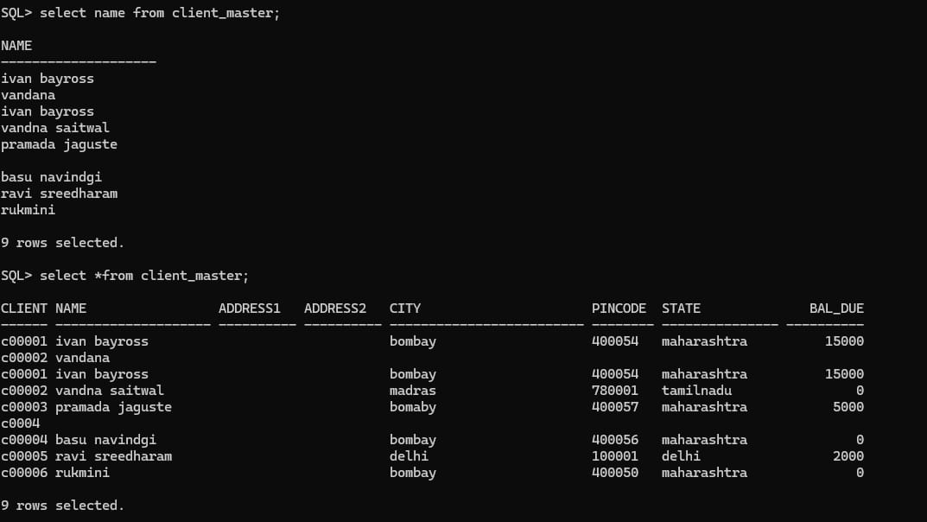

3) Retrieve the list of names and the cities of all the clients.

4) List the various products available from the Product_master table.

**Output:**

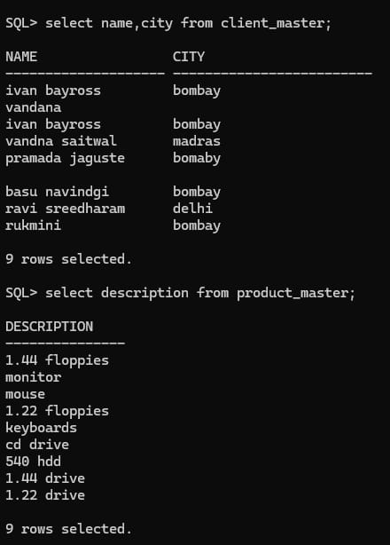

5) List all the clients who are located in Bombay.

6) Find out names of the salesman who have salary equal to Rs. 3000.

**Output:**

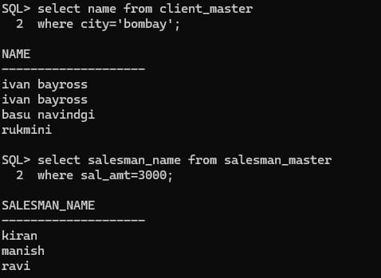

7) Change the city of Client_no ‘C00001’ to ‘Mumbai’.

**Output:**

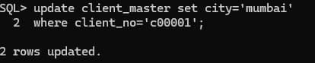

8) Change the bal_due of Client_no ‘C00001’ to Rs. 1000.

**Output:**

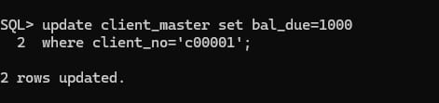

9) Change the cost price of ‘1.22 Floppies’ to Rs. 950.

**Output:**

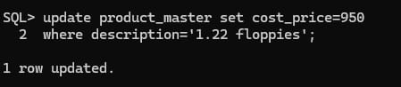

10) Change the city of the salesman to Mumbai.

**Output:**

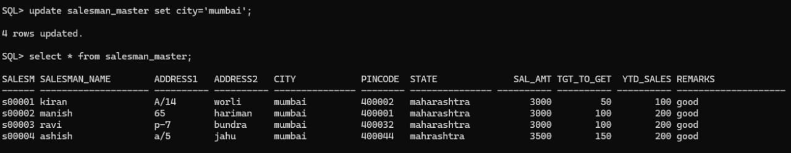

11) Delete all salesman from the salesman_master whose salaries are equal to Rs. 3500.

**Output:**

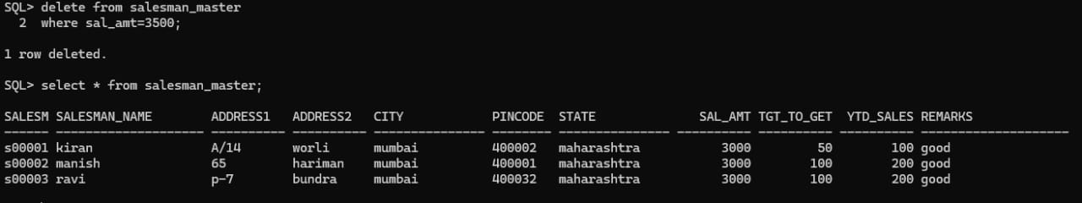

12) Delete all products from product_master where the quantity on hand is equal to 100.

**Output:**

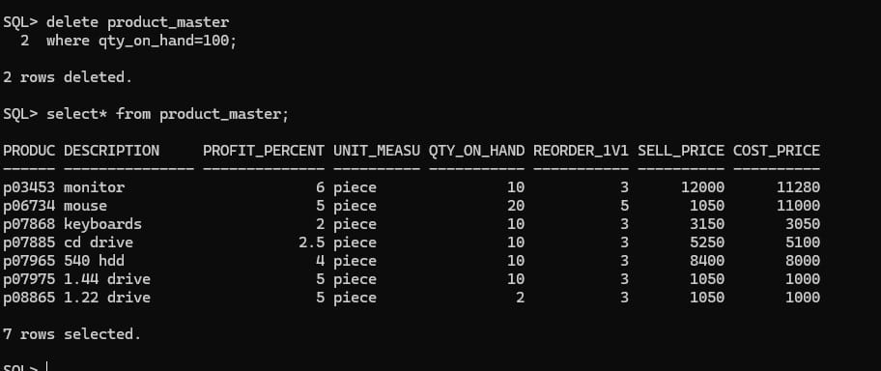

13) Delete from Client_master where the column state holds the value ‘Tamil Nadu’.

**Output:**

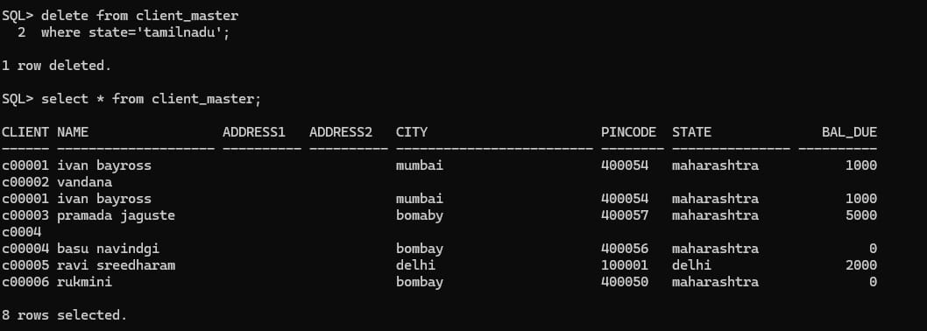

14) Add a column called ‘telephone’ of data type ‘number’ and size =10 to the Client_master table.

**Output:**

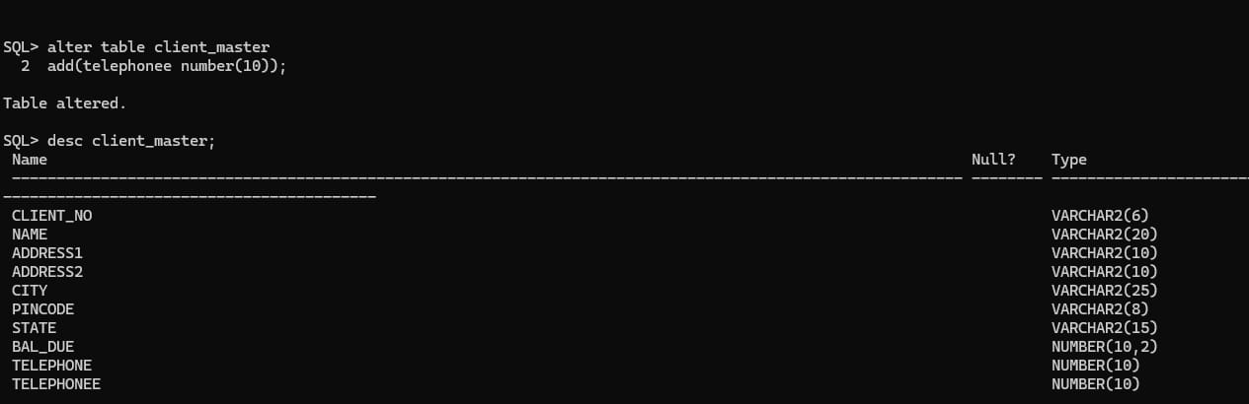

15) Change the size of sell_price column in product_master to 10,2.

16) Destroy the table client_master along with its data.

17) Change the name of salesman_master table to sman_mast.

**Output:**

